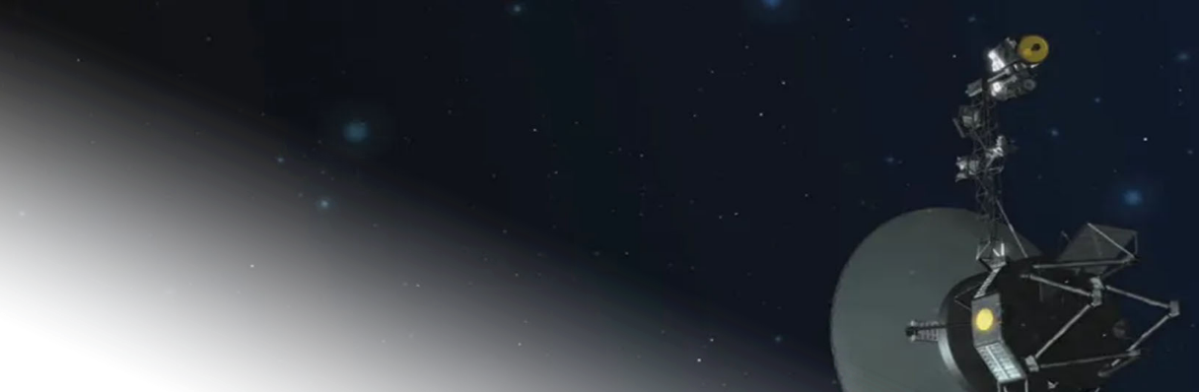

Conquer Stars,
Not Humans

The Conquer Stars, Not Humans Association is a people-driven nonprofit dedicated to education about space and environmental protection.

- Why do you do this?
NASA receives only 0.5% of the federal budget but has brought more than 2,000+ technologies that improve daily life down here. Imagine what more funding can do?
- What do you do?

To educate and inspire kids and adults, both should understand the possible opportunities!
We do:
- Public Cleanup
See
More!
- Interactable Workshops

- Educational Lectures
Conquer Stars,
Not Humans

The Conquer Stars, Not Humans Association is a people-driven nonprofit dedicated to education about space and environmental protection.

- Why do you do this?
NASA receives only 0.5% of the federal budget but has brought more than 2,000+ technologies that improve daily life down here. Imagine what more funding can do?

- What do you do?
To educate and inspire kids and adults, both should understand the possible opportunities!

We do:
- Public Cleanup
See
More!
- Interactable Workshops
- Educational Lectures

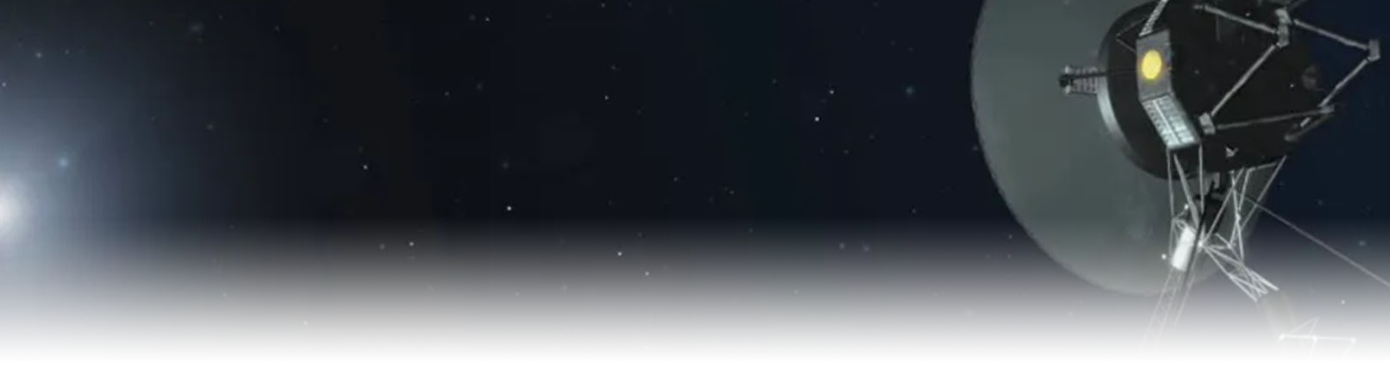

- Why should I help?
GPS, cordless tools, communications, and so much more. All of this can only be done through the exploration of the final frontier. (nasa.gov)

Investments in space innovation lead to breakthroughs in health, safety, and technology you use every day. Why not support it?

- How can I help?
Help us spark curiosity in children and create opportunities for adults. Volunteer in our events, donate to the non-profit, and most importantly share our cause to everyone!

Our end goal:
We want to make sure every child has had a chance to learn about space, and every adult to have an opportunity to venture beyond.

Let’s Conquer Stars, Not Humans.
Visit csinha.org or email info@csinha.org to learn more!

Conquer Stars, Not Humans Association (CSiNHA) is a 501(c)(3) nonprofit organization.
EIN: 39-3477616. Donations are tax-deductible to the extent allowed by law.

- Why should I help?
GPS, cordless tools, communications, and so much more. All of this can only be done through the exploration of the final frontier. (nasa.gov)

Investments in space innovation lead to breakthroughs in health, safety, and technology you use every day. Why not support it?

- How can I help?
Help us spark curiosity in children and create opportunities for adults. Volunteer in our events, donate to the non-profit, and most importantly share our cause to everyone!

Our end goal:
We want to make sure every child has had a chance to learn about space, and every adult to have an opportunity to venture beyond.

Let’s Conquer Stars, Not Humans.
Visit csinha.org or email info@csinha.org to learn more!

Conquer Stars, Not Humans Association (CSiNHA) is a 501(c)(3) nonprofit organization.
EIN: 39-3477616. Donations are tax-deductible to the extent allowed by law.

